Immersed Tunnels - a better way to cross waterways (Tribune - special edition, Mai 1999)
1 - Introduction
The Working Group «IMMERSED TUNNELS» of the International Tunnelling Association was created at the General Assembly in Madrid in 1988.
The aims at that time were to review the different techniques applied in America and Europe and to promote the different technical possibilities, their potential and limits.
Representatives from ten countries, divided into subcommittees, would study the following topics: floating tunnels, seismic aspects, watertightness and seals, design of the size of the steel shell and concrete elements, construction of tunnels and associated marine techniques.
During its 11 years of existence, 3 Animateurs (MM. V. MOLENAAR, P. VAN MILLIGEN and A. GURSOY), 2 Vice-animateurs (MM. A. GURSOY and J. SAVEUR) and 3 Tutors (MM. B. PIGORINI, A. GLERUM and the undersigned) took the Working Group through a lot of new subjects and tasks.
An innovative subject has undoubtly been the introduction, in 1996, of the concept of «SUBMERGED FLOATING TUNNELS», meaning a new system for crossing deep waterways.
The subject has been deepened in cooperation with the European Commission, Directorate General for Transport, that co-financed in 1995 an exhaustive study on the feasibility of the subject.
The most impressive achievement of the Working Group has undoubdly been the publication, as well in 1993 for the Congress of Amsterdam as in 1997 for the World Tunnel Congress of Vienna, of 450 pages of reports concerning the various aspects of the immersed and submerged floating, as well as an exhaustive list of achievements of this kind all over the world; published in two double-sized issues of «Tunnels and Underground Space Technology», the international journal published in cooperation with ITA.
These issues were also presented as independent books for all intended people, and could be considered as the first promotional documents for these outstanding solutions.
The Working Group, in its meeting of 1998 in Sao Paulo, was of the opinion that more should be done to promote the immersed and submerged floating tunnels, than just a few issues of an international journal.
The idea rose very quickly to use «TRIBUNE» , ITA Newsletter, as the vehicle for a much wide, even worldwide, promotion of these solutions, mainly in those countries which encounter the need to cross rivers and other waterways, in a different way than with movable or high bridges allowing navigation.
This first version will be distributed free of charge to all regular destinees of «TRIBUNE», to all participants of the World Tunnel Congress in Oslo and the World Road Congress in Kuala Lumpur in October 1999. Other linguistic versions could be envisaged later, in agreement between the concerned ITA member-nations and the Executive Council. For the future, I suggest that the Working Group goes on with its promotion of these solutions, perhaps with more emphasis on the submerged floating tunnels, for which the preparation of the first achievement across the Høgsfjord, is in its final stage of preparation. The ITA Executive Council is ready to go on to give a maximal support to these efforts.
I sincerely hope, and the ITA Executive Council is following me in this expectation, that this special issue of «TRIBUNE» will contribute in a substancial way to a better knowledge of these selfproven solutions, and to further remarquable achievements all over the world.
I wish to thank all those who contributed to this booklet, both writers and suppliers of photographic material and, last but not least, advertisers
2 - How immersed tunnels are built - part 1
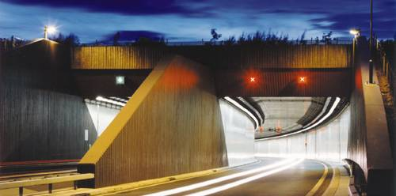
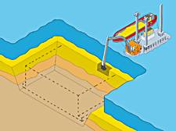
Once completed, an immersed tunnel is no different operationally from any other tunnel. However, it is built in a completely different way. The technique is explained here.
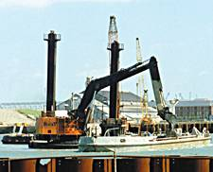
A trench is dredged in the bed of the water channel.
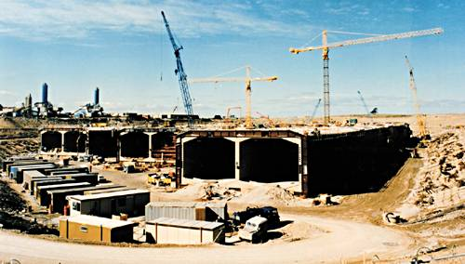
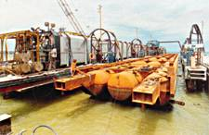
Tunnel elements are constructed in the dry, for example in a casting basin, a fabrication yard, on a ship-lift platform or in a factory unit.
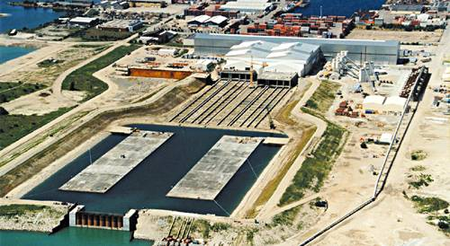
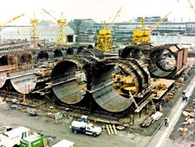
The ends of the element are then temporarily sealed with bulkheads.
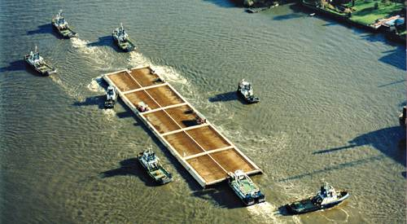
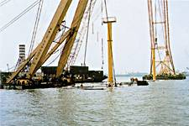
Each tunnel element is transported to the tunnel site - usually floating, occasionally on a barge, or assisted by cranes.
3 - How immersed tunnels are built - part 2
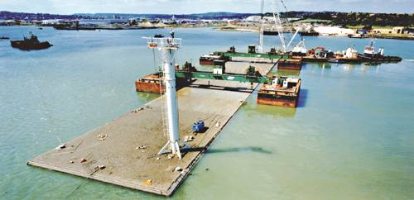
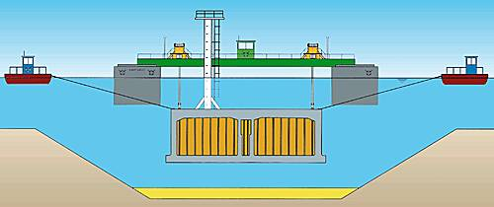
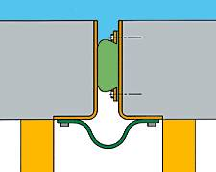
The tunnel element is lowered to its final place on the bottom of the dredged trench.
The new element is placed against the previous element under water. Water is then pumped out of the space between the bulkheads.
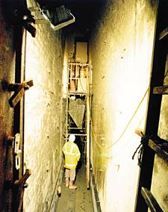
Water pressure on the free end of the new element compresses the rubber seal between the two elements, closing the joint.
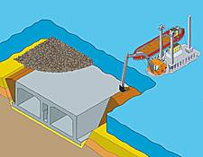
Backfill material is placed beside and over the tunnel to fill the trench and permanently bury the tunnel, as illustrated below.
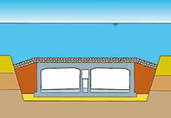
Approach structures can be built on the banks before, after or concurrently with the immersed tunnel, to suit local circumstances.
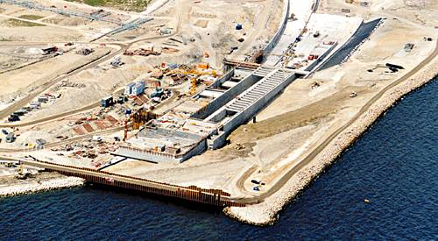
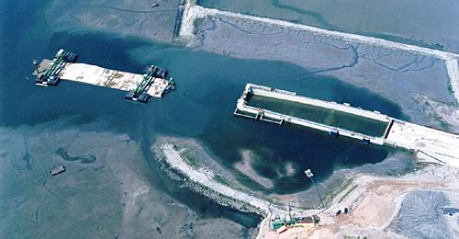
4 - Is it a new idea?
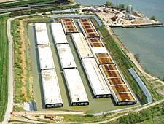
Immersed tunnels have been in widespread use for about 100 years. Over 150 have been constructed all over the world, about 100 of them for road or rail schemes. Others include water supply and electricity cable tunnels. The examples below indicate the diversity of projects that have been realised.
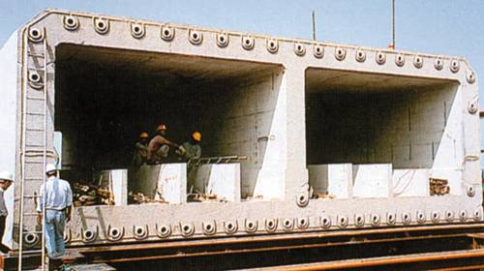
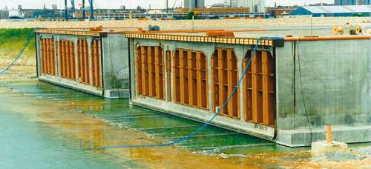
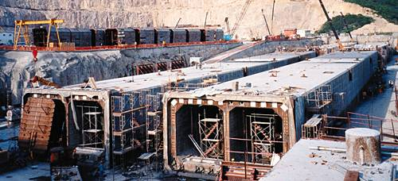
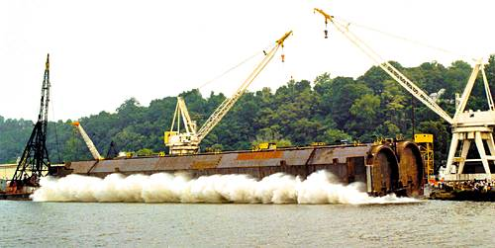
5 - Why choose an immersed tunnel?
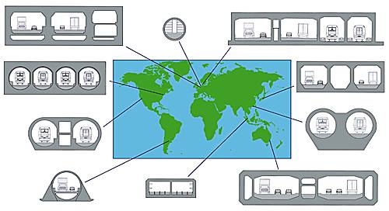
Immersed tunnels do not suit every situation. However, if there is water to cross, they usually present a feasible alternative to bored tunnels at a comparable price, and they offer a number of advantages, such as:
Immersed tunnels do not have to be circular in cross section. Almost any cross section can be accommodated, making immersed tunnels particularly attractive for wide highways and combined road/rail tunnels. Some examples of realised cross sections are shown below.
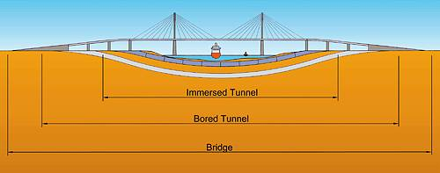
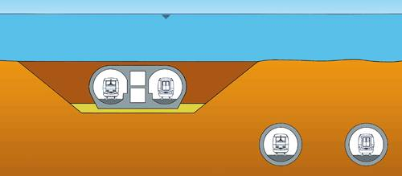
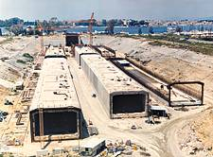
Immersed tunnels can be placed immediately beneath a waterway. In contrast, a bored tunnel is usually only stable if its roof is at least its own diameter beneath the water. This allows immersed tunnel approaches to be shorter and/or approach gradients to be flatter - an advantage for all tunnels, but especially so for railways.
Immersed tunnels can be constructed in ground conditions which would preclude bored tunnelling or render it prohibitively expensive, such as the soft alluvial deposits characteristic of large river estuaries. They can also be designed to deal with the forces and movements in earthquake conditions, as in the example illustrated below, to be placed in very soft ground in an area prone to significant earthquake activity.
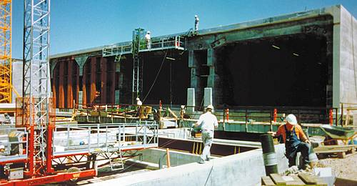
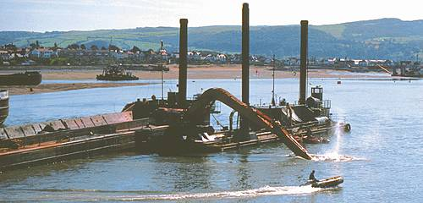
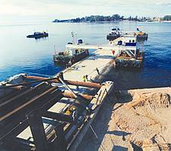
Bored tunnelling is a continuous process in which any problem in the boring operation threatens delay to the whole project. Immersed tunnelling creates three operations - dredging, tunnel element construction and tunnel installation, which can take place concurrently, thus moderating programme risk considerably. Partly for this reason, an immersed tunnel is generally faster to build than a corresponding bored tunnel.
6 - Are there any special problems?
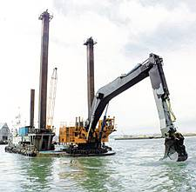
Immersed tunnels are sometimes perceived by newcomers to the technology as "difficult" due to the presence of marine operations. In reality though, the technique is often less risky than bored tunnelling and construction can be better controlled. The marine operations, though unfamiliar to many, pose no particular difficulties. The perceived problems include:
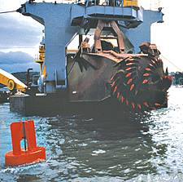
DREDGING
Dredging technology has improved considerably in recent years, and it is now possible to remove a wide variety of material underwater without adverse effects on the environment of the waterway.
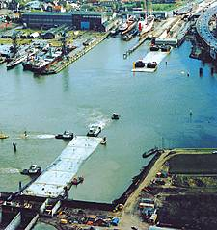
INTERFERENCE WITH NAVIGATION
Interference with navigation: On busy waterways, it is sometimes assumed that construction of an immersed tunnel would be impractical as it would interfere with shipping. In fact, such tunnels have been successfully built in some exceptionally busy waterways without undue problems.
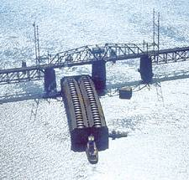
WATERTIGHTNESS
It is often assumed that the process of building a tunnel in water, rather than boring through the ground beneath it will increase the likelihood of leakage. In fact, immersed tunnels are nearly always much drier than bored tunnels, due to the above-ground construction of the elements. Underwater joints depend on robust rubber seals which have proved effective in dozens of tunnels to date.
7 - When should I choose an immersed tunnel?
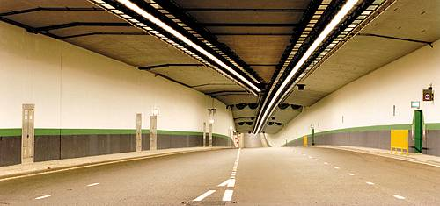
Whenever there is a need to cross water, an immersed tunnel should be considered. The final choice of crossing type will of course depend on many factors. The table below gives an indication of circumstances which favour immersed tunnelling.
ALIGNMENT
Immersed tunnels can be built shallow, permitting shorter tunnels and flatter alignments than bored tunnels.
CROSS SECTION
Immersed tunnel cross sections are highly versatile, making them particularly suitable for wide highways and combined road/railway crossings.
WATER DEPTH
Typically built in between 5m and 30m of water, although schemes have been postulated for 100m depth. Submerged floating tunnel technology (see next chapter) will make water depth immaterial.
GROUND CONDITIONS
Most types of ground can be dealt with, including soft alluvial materials. Conditions unsuited to bored tunnelling do not usually pose a problem. Design for earthquake zones has shown to be perfectly feasible.
LAND AVAILABILITY
Immersed tunnels are often prefabricated remote from the final immersion site, allowing installation in extremely congested (e.g. urban) locations where nearby land is not available.
RECLAMATION
Dredging operations present an opportunity to reshape riverbanks and coastlines as part of a tunnel construction scheme. They are, for example, commonly associated with land reclamation schemes.

8 - A new development: submerged floating tunnels

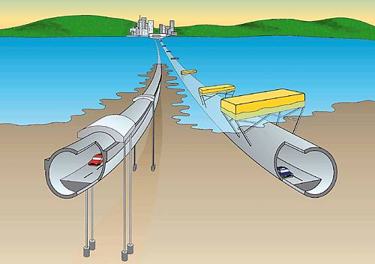

Traditional immersed tunnelling results in a tunnel buried beneath the waterway which it traverses. A new development- the submerged floating tunnel - consists of suspending a tunnel within the waterway, either by tethering a buoyant tunnel section to the bed of the waterway, or by suspending a heavier-than-water tunnel section from pontoons.
This technique has not yet been realised, but one project, in Norway, is currently in the design phase. The submerged floating tunnel allows construction of a tunnel with a shallow alignment in extremely deep water, where alternatives are technically difficult or prohibitively expensive. Likely applications include fjords, deep, narrow sea channels, and deep lakes.

